FIBONACCI WITH RECURSION:

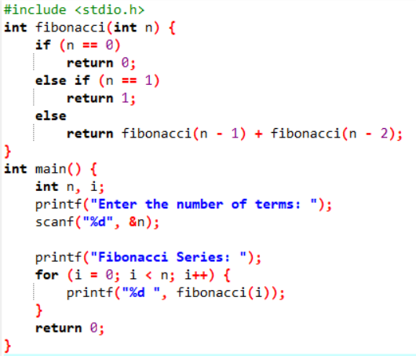

OUTPUT:

